

**NETWORKING & SYSTEM ADMINISTRATION LAB**

**Experiment No.: 4**

**Aim**

Familiarization of basic linux commands

**Procedure:**

1. **cat -n** – print contents with number .

**syntax:**

$cat -n b1.txt

**output:**

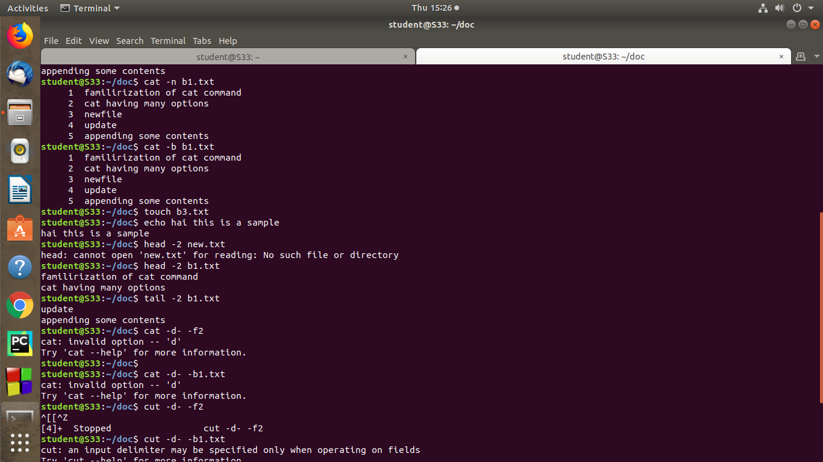

2. **cat -b** - remove the empty lines and redirect the line number.

**syntax:**

$cat -b file.txt

**output:**



3.  **touch-**The touch command allows you to create a blank new file through linux command line.

**syntax:**

$touch b3.txt

**output:**

4.  **echo** -echo command is used to move some data into a file.

syntax:

$echo contents

**output:**



5.**head - T**he head command is used to view the first lines of any text file.

**syntax:**

$head -2 new.txt

**output:**



6. **Tail - Th**is one has a similar function to the head command but instead of showing the first lines ,the

tail command will display the last ten lines of a text file.

**syntax:**

$tail b1.txt



7.**rmdir -**command used to remove a directory .

**syntax:**

$rmdir sample

**output:**